Name : Sundara Moorthy
Reg No : 192324228
Course code : Cloud Computing And Big Data Analysis
Exp No : EXPERIMENT 11
Date : 24/12/2025

EXPERIMENT 11
Title
Changing Hardware Compatibility of an Existing Virtual Machine

Aim
To change the hardware configuration of an already created virtual machine.

Procedure
- Power off the VM.
- Open Settings.
- Modify hardware settings such as CPU, RAM, or storage.
- Alternatively, create a new VM using clone.
- Start the modified VM.

Output
- Virtual machine runs with updated hardware configuration.
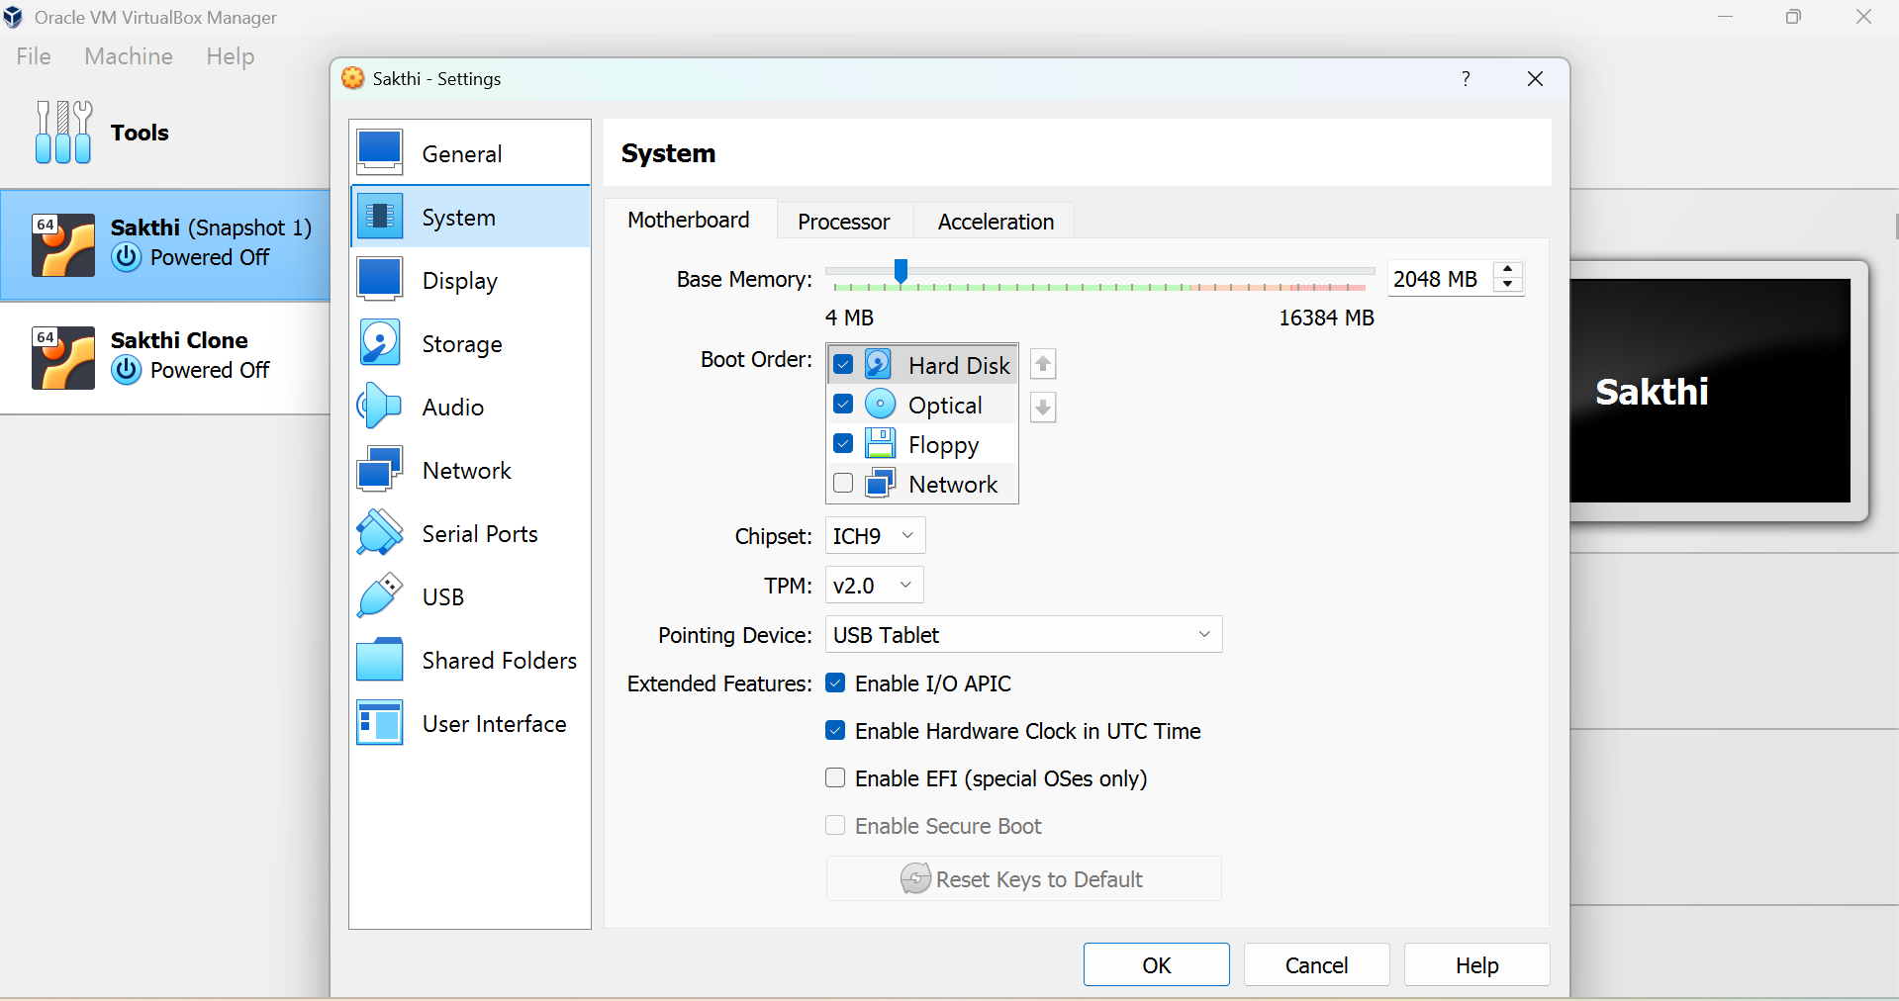

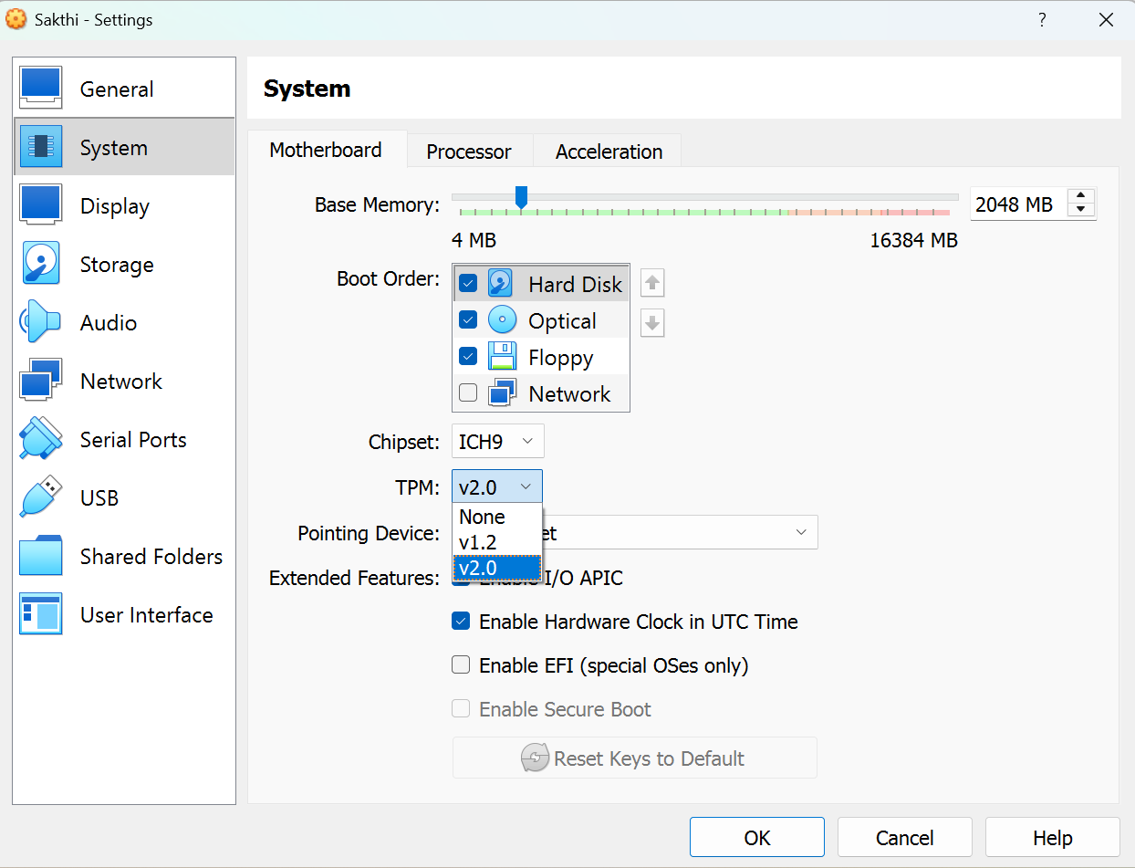

Result
Thus, hardware compatibility of an existing virtual machine was successfully modified using VirtualBox.

